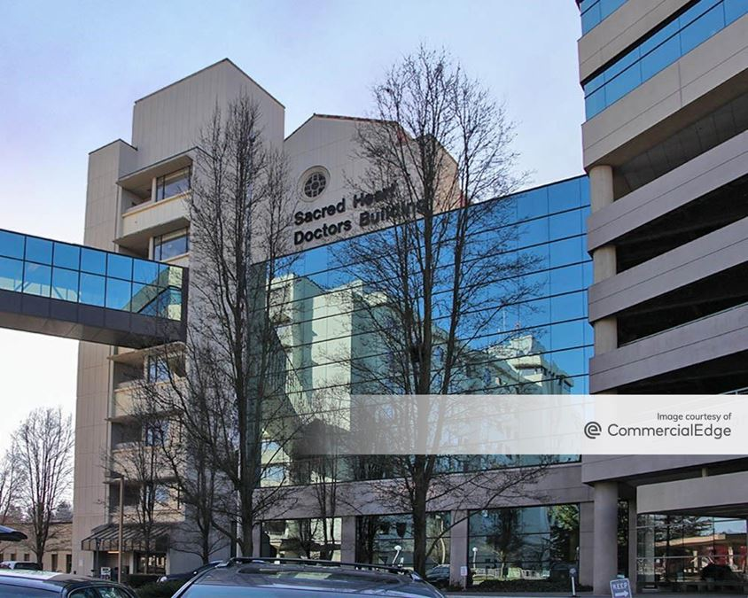

Providence Sacred Heart Pharmacotherapy Clinic– PGY1

# Residency Manual

5/16/2024

Table of Contents

1. Recruitment and Selection of Residents 1

1.1 Documented Procedure for Selection of Residents 1

1.2 Requirements of Applicants 2

1.3 ASHP Pharmacy Resident Match Program 2

Salary and Benefits 3

2. Program Requirements and Policies 4

2.1 Length of Program 4

2.2 Time Away 4

2.3 Duty Hours 6

2.4 Requirements for Licensure 6

2.5 Requirements for Successful Completion of the Program 7

2.6 Remediation/Disciplinary Policy 8

2.7 Procedure for Verifying Completion of PGY1 Program 9

2.8 Documents Provided During the Interview 9

2.9 Confirmation and Acceptance of Match Results 9

2.10 Policy Review 9

2.11 Resident Manual 9

2.12 Resources Available to Residents 9

2.13 Awarding the Residency Certificate of Completion 10

2.14 Residency Certificate of Completion Example 10

2.15 Program’s Compliance with ASHP 10

2.16 Authority Over the Program 10

3. Structure, Design, and Conduct of the Residency Program 11

3.1 Program Structure and Design 11

3.2 Learning Experiences 15

3.3 Development Plans 16

3.4 Evaluation of the Resident 17

3.5 Evaluation of the Preceptor and Learning Experience 19

4. Requirements of the RPD and Preceptors 20

4.1 Requirements of the Program 20

4.2 RPD Eligibility 20

4.3 RPD Qualifications 20

4.4 Program Oversight 20

4.5 Pharmacist Preceptors’ Eligibility 21

4.6 Preceptors’ Qualifications 21

4.7 Active Practice and Ongoing Responsibilities 24

4.8 Non-Pharmacist Preceptors 25

5. Pharmacy Services 26

5.1 Pharmacy Leadership 26

5.2 Medication Use Systems 27

5.3 Patient-Centered Care 27

Appendix A: Virtual Event Flyer 28

Appendix B: Extended and Family Medical Leave Policy 30

Appendix D: Licensure Policy 36

Appendix E: Dismissal and Disciplinary Policy 38

Appendix F: Graduation Checklist 42

Appendix G: Sample Post Match Communication 47

Appendix H: Sample Certificate of Completion 50

Appendix I: Sample Resident Development Plan 51

List of Figures

**No table of figures entries found.**

List of Tables

**No table of figures entries found.**

**About Providence**

Providence is the largest health care provider in Washington with hospitals, clinics, senior care centers, hospice, and home health services in communities – large and small – across the state. Our not-for-profit network includes hospitals, physicians, clinics, care centers, [hospice and home health programs](https://gme.providence.org/services/providence-home-and-community-care) and diverse community services across Washington. Our health care services in Washington include unique affiliations with [Swedish Health Services](https://www.swedish.org/) and [Pacific Medical Centers](https://www.pacificmedicalcenters.org/) in Western Washington and [Kadlec](https://www.kadlec.org/) in Eastern Washington.

We believe health care is a basic human right. We're here to serve the evolving needs of the communities we serve and make excellent health care available to all. Our focus on providing our communities with the full continuum of care makes Providence a model in Washington state and beyond. We work collaboratively across traditional boundaries to develop patient-centered practices that help make lifelong quality care accessible and affordable.

When Mother Joseph and the Sisters of Providence founded Sacred Heart Medical Center in 1886, it was a small 31-bed facility build along the Spokane river. Since then, we’ve become a major regional medical center featuring the best doctors, specialists and staff around.

**Mission Statement**

As expressions of God's healing love, witnessed through the ministry of Jesus, we are steadfast in serving all, especially those who are poor and vulnerable.

**Core Values**

Compassion - Dignity - Justice - Excellence - Integrity

**Vision**

Health for a better world.

**Residency Program Purpose**

The purpose of the PGY1 pharmacy residency program is to build on Doctor of Pharmacy (Pharm.D.) education and outcomes to contribute to the development of clinical pharmacists responsible for medication-related care of patients with a wide range of conditions, eligible for board certifications, and eligible for postgraduate year two (PGY2) pharmacy residency training.

## Recruitment and Selection of Residents

The residency program has a documented procedure that is used by all involved in the recruitment, evaluation, and ranking of applicants. The program ensures applicants meet all criteria set forth by the ASHP accreditation standards.

### Documented Procedure for Selection of Residents

Providence Sacred Heart Pharmacotherapy Clinic ensures each pharmacy resident candidate is evaluated and ranked in a standardized manner that promotes diversity and inclusion.

1.1a – Diversity and inclusion during recruitment

The residency program hosts various virtual open house events for candidates who are unable to visit the program booth at ASHP Midyear. Open house events are advertised on the ASHP residency directory listing for the program and on the program website. Virtual open house events are offered at various times and dates to account for time zone differences. Contact information for the program is also available on the ASHP residency directory listing and program website for candidates who are unable to attend the virtual open house events and/or the residency showcase at the ASHP Midyear Clinical Meeting. See Appendix A for the virtual event flyer.

1.1b – Determining which applicants shall be invited to interview

Applicants to the pharmacy residency program must be graduates or candidates for graduation of an Accreditation Council for Pharmacy Education (ACPE) accredited degree program (or one in process of pursuing accreditation) or have a Foreign Pharmacy Graduate Equivalency Committee (FPGEC) certificate from the National Association of Boards of Pharmacy (NABP) and be licensed or eligible for licensure in the state of Washington. The Resident Selection policy is available to leadership and the accreditation board upon request, but not available to applicants to maintain integrity of the application selection process. Initial application screening will be performed by members of the RAC. Rubrics are available to leadership and the accreditation board upon request, but not available to applicants to maintain integrity of the interview process.

1.1c – Evaluating each applicant’s interview performance

The day of interview process will be conducted as described in the Resident Selection policy. This policy is available to leadership and the accreditation board upon request, but not available to applicants to maintain integrity of the interview process. Pre-determined grading rubrics will be used for each step of the interview process. Rubrics are available to leadership and the accreditation board upon request, but not available to applicants to maintain integrity of the interview process.

1.1.d – How the rank order of applicants for the Match is determined

Applicants will be ranked as described in the Resident Selection policy. This policy is available to leadership and the accreditation board upon request, but not available to applicants to maintain integrity of the Match list process.

1.1.e – Phase II Match procedure

If there are open positions after Phase I of the match, the program will participate in Phase II as described in the Resident Selection policy. This policy is available to leadership and the accreditation board upon request, but not available to applicants to maintain integrity of the phase II process.

1.1.f Early Commitment Procedure

This is not applicable to this residency program as a PGY1

### Requirements of Applicants

Due to the highly clinical nature of pharmacy practice in the state of Washington, applicants must be able to learn and manage a variety of disease states which requires physical and mental stamina. Applicants must display critical thinking and problem-solving skills, empathy for others, and sound clinical judgment to ensure patient safety. Applicants must conduct themselves in a professional manner towards health care providers, patients, family members, and preceptors by being emotionally stable and mature.

Upon matching with our program, residents will be required to fill out an online application through our normal human resources recruitment process. Successful completion of pre-employment screening including, but not limited to, a drug screen and background check will be required.

1.2.a – Licensure of applicants

Applicants to the pharmacy residency program must be graduates or candidates for graduation of an Accreditation Council for Pharmacy Education (ACPE) accredited degree program (or one in process of pursuing accreditation) or have a Foreign Pharmacy Graduate Equivalency Committee (FPGEC) certificate from the National Association of Boards of Pharmacy (NABP) and be licensed or eligible for licensure in the state of Washington.

1.2.b – Completion of ASHP accredited or candidate-status PGY1 residency

Not applicable to our program as PGY1

1.2.c – Applicants to International Programs

Not applicable for our program

### ASHP Pharmacy Resident Match Program

Providence Sacred Heart Pharmacotherapy Clinic PGY1 pharmacy residency program abides by the rules for the ASHP Pharmacy resident matching program. For more information regarding the rules for the ASHP pharmacy resident matching program please visit <https://natmatch.com/ashprmp/documents/ashpmatchrules.pdf>.

### Salary and Benefits

Resident Salary

Residents will be paid a competitive stipend for their residency experience. Residents will be paid every other Friday. There is a total of 26 pay periods during the residency experience; the stipend will be divided equally among the pay periods.

Insurance

Medical, vision, and dental insurance is provided through Providence Health and Services for residents and family members living in their home.

Residents receive basic life insurance along with long- and short-term disability.

Residents must have professional liability insurance as required for provider credentialing. The expense of this is included in the resident’s annual stipend.

Paid Time Off (PTO)

Residents receive 25 days of paid time off/safe sick leave with 7 of those days being assigned to holidays. Holidays include New Year’s Day, Martin Luther King Jr. Day, Memorial Day, 4th of July (when not at Camp STIX), Labor Day, Thanksgiving, and Christmas Day. PTO can carry forward if employed by Providence after residency.

Mental Health Resources

All residents, faculty, and staff have access to digital and inperson cognitive behavioral therapy services to support individual well-being.

Professional Memberships

Residents are required to join ASHP, Washington State Pharmacist’s Association (WSPA), and Spokane Pharmacist’s Association (SPA). Membership fees are included in the resident’s stipend.

## Program Requirements and Policies

This section discusses the specific requirements and policies of the program.

### Length of Program

The minimum term of resident appointment is 52 weeks. The program is currently 52 weeks.

### Time Away

Resident policies define the amount of time residents are allowed to be away from the program.

2.2.a – Allotted Time Away

In accordance with the ASHP accreditation standards, residents are allowed to miss up to 37 days of their residency training without having to extend their residency year. Time away from the program includes vacation time, sick time, holiday time, religious time, interview time, personal time, jury duty time, bereavement leave, military leave, parental leave, leave of absence, and extended leave. Conference or education days, despite being a required part of the program, are also included in the number of days away from the program. Breakdown of anticipated time away from the program are as follows:

|  |  |
| --- | --- |
| **Event** | **Number of Days** |
| ASHP Midyear | 4 |
| PICAT | 1 |
| Regional Conference | 4 |
| Holiday Time | 7 |
| **TOTAL REQUIRED** | **16** |
| Paid Time Off | 11 |
| Safe Sick | 7 |
| **TOTAL DAYS AWAY** | **34** |
|  |  |

**Vacation Requests:**

Vacation requests that are one to two days in a row must be discussed with the preceptor of the rotation that the resident is planning to miss. Once approved by the preceptor, the resident must submit a request in writing via email to the residency program director or designee with the preceptor cc’d on the email. Approvals will be granted in writing. Residents cannot request vacation on staffing days if they already have patients on their schedule or if the schedule has been posted in StaffReady. Residents must maintain 90% attendance with all rotations when requesting time away from rotation.

**Personal Appointments:**

Personal appointments for places with normal business hours (medical, banking, etc) should have minimal impact on rotation activities. Appointments need to be approved by the preceptor prior to the start of the rotation. If the appointment was made after the start of the rotation the appointment must be approved by the preceptor at least two days prior to the appointment. Exceptions will be made on a case-by-case basis. Residents must maintain 90% attendance with all rotations when requesting time away from rotation.

Personal appointments for places with extended business hours (hair, nails, car dealers, etc) must be scheduled during non-rotation time.

**Sick Leave:**

Sick leave may be used for personal illness, disability, or injury; care for a child less than 18 years of age with a health condition that requires treatment or supervision; and care for a spouse, registered domestic partner, parent, parent-in-law, or grandparents with an illness, injury, or serious health condition.

Residents must contact the RPC and preceptor at least 2 hours in advance to miss rotation experiences. Any time missed from rotation that causes a less than 90% attendance rate must be made up even if this means extending the residency experience.

**Emergency/Extended Leave:**

We understand that unexpected life events happen. We want to see our residents succeed and reasonable accommodations will be made as outlined in the extended and family medical leave policy.

**Professional Leave:**

Residents will be granted professional leave for required conferences with reasonable time away for travel.

**Maternity and Paternity Leave:**

Congratulations on your new bundle of joy! We support moms recovering from childbirth and both parents bonding with their baby. If you need maternity or parental leave during your residency year, we will accommodate this as outlined in the extended and family medical leave policy.

**Leave of Absence:**

Requests for a leave of absence will follow the extended and family medical leave policy.

**Professional Meetings and Travel:**

Residents are required to attend the Midyear ASHP clinical meeting, and a regional residency conference. Flights to Midyear and other conferences if needed are booked through the Providence travel website. Residents will be reimbursed for meeting registrations (at early bird rates), meals (up to $95 per day excluding alcohol), lodging (for Midyear and regional conference only), and transportation to/from the airport; reimbursement occurs through Concur. Expenses without receipts are not reimbursable.

2.2.b – Extension of the Program

Leave beyond the allotted 37 days (shifts) away will result in an extension of the residency year as outlined in the Dismissal and Disciplinary and Extended Family Medical Leave Policy (Appendix B). It is preferable that leave without pay will not exceed 6 months such that graduation will occur prior to December 31st of the original expected year of graduation. Termination from the program is an option and will be favored if the previous criteria cannot be met. If leave during the residency year was paid, the extension of the residency year will not be paid.

### Duty Hours

Providence Sacred Heart Pharmacotherapy Clinic ensures compliance with the ASHP Duty Hour Requirements for Pharmacy Residencies through the development of program policies and processes as it applies to the following areas:

2.3.a – Web link for the ASHP Duty Hour Requirements for Pharmacy Residencies

A link to the ASHP Duty Hour Requirements is included in the Duty Hour Policy (Appendix C) and can be found at <https://www.ashp.org/-/media/assets/professional-development/residencies/docs/duty-hour-requirements.ashx>.

2.3.b – Process for monitoring compliance monthly

Documentation of compliance with all duty hour requirements including hours worked and hours free of work will be done through PharmAcademic. It is important for residents to remain compliant with the duty hour policy (Appendix C) for resident wellbeing and patient safety.

2.3.c – Moonlighting

Moonlighting is not allowed during this residency program.

2.3.d – On-Call Programs

There are no on-call requirements for this residency program.

### Requirements for Licensure

Providence Sacred Heart Pharmacotherapy Clinic ensures compliance with the ASHP licensing requirements as outlined in the ASHP Accreditation Standards.

2.4.a – State Licensing

Residents are required to be licensed in the state of Washington within 90 days of the program start date. See licensing policy (appendix D) for full policy.

2.4.b – Licensing Policy

Licensure deadline and information regarding licensing is outlines in the Licensure Policy (appendix D)

### Requirements for Successful Completion of the Program

Requirements for successful completion of the program are outlined below. See Appendix F for a comprehensive graduation checklist.

2.5.a – Requirements for overall achievement of educational objectives for residency

Residents must “achieve for residency” 90% of all goals and objectives.

2.5.b – List of deliverables related to educational objectives

| **Objective #** | **Deliverable** | **Guidance** |
| --- | --- | --- |
| R1.4.2 | Drug class review, monograph, treatment guideline, treatment protocol, utilization management criteria, and/or order set. | Completion requirements must include one of the above; programs may set their completion requirements higher |
| R2.1.2 | Develop a project plan as defined in the Objective and Criteria. | Each resident is required to complete a major project; defined as a longitudinal project with significant breadth intended to advance pharmacy practice. All Objectives (2.1.1-2.1.6) must be assigned to be taught and evaluated for the major project. Project reports for the major project include both: • Platform style or poster presentation to an external audience (e.g., regional residency conference or comparable professional meeting). • Written report (e.g., manuscript and/or formal written report suitable for invested parties). The second project report summarizes work on another project which can be major or minor in scope. Examples of minor projects include MUE, |
| R2.1.6 | Project report(s) for at least two projects: • Major project • Second project | See R2.1.2 above |
| R4.1.1, R4.1.2, and R4.1.3 | Completion requirements must include one verbal and one written example; programs may set their completion requirements higher. | • Verbal presentation (e.g., audiovisual / slides, presentation handout). • Written example may include of any of the following: o Patient education (e.g., brochure, handout) o Education to health care provider (e.g., newsletter, medication or disease management update) o Education to pharmacists (e.g., guideline update) |

2.5.c – Appendix requirements

This program does not have appendix requirements

2.5.d – Other requirements

Residents must satisfactorily complete all rotations and maintain 90% attendance for each rotation. Residents must make reasonable progress in their quality improvement projects as determined by the RPD. Residents must complete and submit a manuscript to a journal of their choice and present their project at ASHP Midyear in poster form and in PowerPoint form at a regional residency conference.

### Remediation/Disciplinary Policy

We are invested in our residents and their success during our program. In the unlikely event that residents are unable to meet the expectations of the program, disciplinary actions will be taken in accordance with the Dismissal and Disciplinary policy (Appendix E).

### Procedure for Verifying Completion of PGY1 Program

Does not apply to this program as a PGY1

### Documents Provided During the Interview

Applicants invited to interview will be provided a copy of the resident manual which includes leave policies, duty-hour policies, licensure policy, requirements for successful completion of the program, residency-specific remediation/disciplinary policy, program start date and term of appointment, stipend and benefit information, and how the program financially supports residents to attend required professional meetings. Applicants invited to interview are also provided with a sample schedule and the human resources (HR) leave policy.

### Confirmation and Acceptance of Match Results

Within 30 days of the Match, the RPD or designee will contact each matched candidate through PhORCAS to request candidates confirm their acceptance of the Match by applying to the resident job posting through Providence’s career site. Candidates will be given one week to confirm their acceptance and begin the HR screening process. Matched candidates will be given their contract to sign. A sample communication can be found in Appendix G.

### Policy Review

Matched candidates will meet with the RPD during the first two weeks of the start of the residency program, during orientation, to review and sign program policies.

### Resident Manual

This residency manual includes information on the practice site, program structure, program participants and roles, completion requirements, residency policies (or information on where located), program overall evaluation strategy including evaluations required and the defined rating scale for summative evaluations, and other information pertinent to residents. The manual is reviewed and updated annually.

### Resources Available to Residents

Residents have access to all resources (clinical information systems, databases, references, etc.) available to other Providence providers.

2.12.a – Workspace

Residents will have a designated area to work at each clinic that is safe and conducive to concentrating without frequent interruptions.

2.12.b – Technology

Residents have access to electronic medical records, compendia (including Micromedex, Up-To-Date, and the Natural Medicine’s Database), primary literature thought the Providence library, and all other technology needed to be successful with their residency training. Residents are not required to work from home but may do so through remote access using their personal electronic devices or Providence provided work laptop.

### Awarding the Residency Certificate of Completion

The RPD or designee will award a residency certificate of completion only to those who complete the program’s requirements. Residents’ completion of the program’s requirements is documented by the RPD or designee in PharmAcademic and on the resident development plan. The requirements for awarding a certificate of completion can be found in section 2.5 (Requirements for Successful Completion of the Program).

### Residency Certificate of Completion Example

A certificate of completion is provided to residents who complete the program’s requirements and is issued in accordance with the provisions of the ASHP Regulations on Accreditation of Pharmacy Residencies. The certificate is signed by the RPD and chief executive officer (or appropriate executive) and includes the organization name, residency program type, city and state, and accreditation status. An example of the certificate of completion can be found in Appendix H.

### Program’s Compliance with ASHP

The RPD maintains the program’s compliance with the provisions of the current version of the ASHP Regulations on Accreditation of Pharmacy Residencies. The program uses the approved program-type name (PGY1- Pharmacy) and PharmAcademic for residency program management and maintenance including objective assignment, learning experience descriptions, residents’ schedules, evaluations, residents’ development plans, and resident close-out documentation. The program keeps a record of each residents’ program application, acceptance letter, documented acceptance of program policies; copy of each resident’s licensure, deliverables, documentation of completion requirements; and each resident’s signed residency certificate of completion since the last accreditation site survey.

### Authority Over the Program

Providence Health and Services is the only organization who has responsibility for the financial and/or management aspects of the residency program. This is not a multiple practice-site residency

## Structure, Design, and Conduct of the Residency Program

This section describes the program structure, design, and conduct. The program’s structure and design enable residents to achieve the purpose of the residency program through skill development in the program’s required competency areas. This section defines requirements for oversight of residents’ development, formative and summative evaluations, and self-assessment. This section also addresses continuous program improvement

### Program Structure and Design

This residency program is designed to allow residents to gain experience and independent practice with a variety of learning experiences. The design of this program ensures that at least half of the residency year is scheduled in required learning experiences including longitudinal experiences.

3.1.a (1-4) – Learning experience designations, type, and duration

The residency program consists of required, and elective learning experiences. The required experience consists of eight block and five longitudinal rotations. Once the staffing rotation starts, block rotations are four days per week. Brief descriptions of our learning experiences can be found on our program website. A list of experiences are as follows:

| **Experience** | **Designation** | **Type** | **Duration** |
| --- | --- | --- | --- |
| Anticoagulation | Required | Block | 5 weeks |
| Anticoagulation Triage | Required | Block | 5 weeks |
| Centralized Refill | Required | Longitudinal | Length of program |
| Community Outreach | Required | Longitudinal | Length of program |
| Disease State Management One | Required | Block | 5 weeks |
| Disease State Management Two | Required | Block | 5 weeks |
| Geriatrics | Elective | Block | Varies |
| Management | Required | Block | 5 weeks |
| Obstetrics | Required | Block | 5 weeks |
| Orientations | Required | Block | 4 weeks |
| Outpatient | Elective | Block | Varies |
| Pharmacy Informatics | Elective | Block | varies |
| Primary Care | Required | Block | 5 weeks |
| Quality Improvement | Required | Longitudinal | Length of program |
| Staffing | Required | Longitudinal | Length of program |
| Teaching Certificate | Required | Longitudinal | Length of program |
| Transitions of Care | Elective | Block | varies |

3.1.b – Competency areas, goals, and objectives

The residency program’s structure supports the program’s purpose and facilitates achievement of all required objectives. All required objectives are assigned to at least one required learning experience with most assigned to a sequence of learning experiences to allow sufficient practice for achievement. The competency areas, goals, and objectives are as follows:

**Competency Areas**

1. Patient Care (R1)
2. Advancing Practice and Improving Patient Care (R2)
3. Leadership and Management (R3)
4. Teaching, Education, and Dissemination of Knowledge (R4)

**Goals**

1. R1.1: Provide safe and effective patient care services following JCPP (Pharmacists’ Patient Care Process).
2. R1.2: Provide patient-centered care through interacting and facilitating effective communication with patients, caregivers, and stakeholders.
3. R1.3: Promote safe and effective access to medication therapy.
4. R1.4: Participate in the identification and implementation of medication-related interventions for a patient population (population health management)
5. R2.1: Conduct practice advancement projects.
6. R3.1: Demonstrate leadership skills that contribute to departmental and/or organizational excellence in the advancement of pharmacy services.
7. R3.2: Demonstrate leadership skills that foster personal growth and professional engagement..
8. R4.1: Provide effective medication and practice-related education.
9. R4.2: Provide professional and practice-related training to meet learners’ educational needs.

**Objectives**

Learning experiences evaluating each competency area can be found in green next to each objective. Electives will further add experience in various competency areas but are not necessary to meet all assigned goals/objectives.

1. R1.1.1 (Analyzing) Collect relevant subjective and objective information about the patient. (Anticoagulation, Refill, Transitions of Care)
2. R1.1.2 (Evaluating) Assess clinical information collected and analyze its impact on the patient’s overall health goals. (DSM1, Primary Care)
3. R1.1.3 (Creating) Develop evidence-based, cost effective, and comprehensive patient centered care plan(Obstetrics, DSM2)
4. R1.1.4: (Applying) Implement care plans. (Anticoagulation, Obstetrics)
5. R1.1.5: (Creating) Follow-up: Monitor therapy, evaluate progress toward or achievement of patient outcomes, and modify care plans. (DSM1, AC triage)
6. R1.1.6: (Analyzing) Identify and address medication-related needs of individual patients experiencing care transitions regarding physical location, level of care, providers, or access to medications. (Primary Care, Anticoagulation)
7. R1.2.1: (Applying) Collaborate and communicate with healthcare team members (AC triage, Refill, Transition of Care)
8. R1.2.2: (Applying) Communicate effectively with patients and caregivers. (DSM1, Staffing, Geriatrics)
9. R1.2.3: (Applying) Document patient care activities in the medical record or where appropriate. (DSM2, Obstetrics, Geriatrics)
10. R1.3.1: (Applying) Facilitate the medication-use process related to formulary management or medication access. (DSM2, Refill)
11. R1.3.2: (Applying) Participate in medication event reporting (Anticoagulation, AC triage)
12. R1.3.3: (Evaluating) Manage the process for preparing, dispensing, and administering (when appropriate) medications. (DSM2, Staffing)
13. R1.4.1: (Applying) Deliver and/or enhance a population health service, program, or process to improve medication-related quality measures. (Primary Care, Anticoagulation)
14. R1.4.2: (Creating) Prepare or revise a drug class review, monograph, treatment guideline, treatment protocol, utilization management criteria, and/or order set. (Quality Improvement)
15. R2.1.1: (Analyzing) Identify a project topic, or demonstrate understanding of an assigned project, to improve pharmacy practice, improvement of clinical care, patient safety, healthcare operations, or investigate gaps in knowledge related to patient care (Quality Improvement)
16. R2.1.2: (Creating) Develop a project plan. (Quality Improvement)
17. R2.1.3: (Applying) Implement project plan. (Quality Improvement)
18. R2.1.4: (Analyzing) Analyze project results. (Quality Improvement)
19. R2.1.5: (Evaluating) Assess potential or future changes aimed at improving pharmacy practice, improvement of clinical care, patient safety, healthcare operations, or specific question related to patient care (Quality Improvement)
20. R2.1.6: (Creating) Develop and present a final report. (Quality Improvement)
21. R3.1.1: (Understanding) Explain factors that influence current pharmacy needs and future planning (Management, Informatics)
22. R3.1.2: (Understanding) Describe external factors that influence the pharmacy and its role in the larger healthcare environment. (Management)
23. R3.2.1: (Applying) Apply a process of ongoing self-assessment and personal performance improvement. (Orientation, Staffing)
24. R3.2.2 (Applying) Demonstrate personal and interpersonal skills to manage entrusted responsibilities. (Refill, Staffing, Outpatient)
25. R3.2.3: (Applying) Demonstrate responsibility and professional behaviors. (Management, DSM1, Outpatient)
26. R3.2.4: (Applying) Demonstrate engagement in the pharmacy profession and/or the population served. (Primary Care, Managment)
27. R4.1.1: (Creating) Construct educational activities for the target audience. (Community Outreach)
28. R4.1.2: (Creating) Create written communication to disseminate knowledge related to specific content, medication therapy, and/or practice area(Community Outreach, Teaching Certificate)
29. R4.1.3: (Creating) Develop and demonstrate appropriate verbal communication to disseminate knowledge related to specific content, medication therapy, and/or practice area. (Community Outreach, Teaching Certificate)
30. R4.1.4: (Evaluating) Assess effectiveness of educational activities for the intended audience (Community Outreach, Teaching Certificate)
31. R4.2.1: (Evaluating) Employ appropriate preceptor role for a learning scenario. (Teaching Certificate, Geriatrics)

3.1.c – Program Design Requirements

This program is designed to allow residents to gain experience and independent practice with a variety of disease states and conditions. Residents will gain experience in recurring follow-up of patients in several block learning experiences and staffing. This program is designed to have residents spend at least two thirds of their time in patient care activities, and no more than one-third of direct patient care learning experiences will focus on a specific disease state.

### Learning Experiences

3.2.a – Learning experience descriptions

Preceptors create learning descriptions unique to their learning experience. Each learning experience includes a general description, including the practice area; the role of pharmacists in the practice area; expectations of residents; resident progression; objectives assigned to the learning experience; and a list of learning activities that facilitate achievement of each objective. Learning experience descriptions are documented and maintained in PharmAcademic.

3.2.b – Learning experience review

At the beginning of each learning experience, preceptors will orient residents to the learning experience using the learning experience.

3.2.c – Preceptor roles

Preceptors will use the appropriate preceptor role based on each resident’s progression through the learning experience. The four precepting roles are follows:

|  |  |
| --- | --- |
| **Role** | **Description** |
| Direct instruction | Preceptors directly teaching residents. This role is typically used with students and will only be used with residents when needed and at a level appropriate for a resident. |
| Modeling | Preceptors model the practice skill described in the educational objective. This is done through activities such as shadowing patient visits. |
| Coaching | Preceptors provide regular, on-going feedback to the resident. An example would be the preceptor observing a patient visit then providing feedback to the resident following the visit. |
| Facilitating | Preceptors allow residents to assume increasing levels of responsibility for performance of skills with indirect support of the preceptor as needed. An example would be the preceptor allowing the resident to complete patient visits independently with the preceptor available if the resident needs help or has questions. |

### Development Plans

Each resident will complete a self-assessment prior to the start of the residency as part of their initial development plan. This information will be used to create the resident development plan. The development plan is a high-level summary of the resident’s performance and progress throughout the program. Development plans support resident’s practice interests, career development, and resident well-being and resilience. Development plans will also track progress towards completion of program requirements.

3.3.a – Resident self-assessment

Resident self-assessment includes both self-reflection and self-evaluation. Self-reflection is defined as thinking about oneself, including behavior, values, knowledge, and growth opportunities. Residents document self-reflection on career goals, area of clinical interest, personal strengths and opportunities for improvement, and stress management strategies. Self-evaluation is comparing one’s performance to a benchmark. Entering Resident Self-Assessment Form will be uploaded to PharmAcademic.

3.3.b/c – Initial development plan

Based on the results of the resident's initial self-assessment, initial development plans will be created, discussed, and documented with each resident within 30 days of starting the residency. Finalized plans will be shared with preceptors through PharmAcademic. An example of a resident development plan can be found in Appendix I.

3.3.d – Ongoing development plan

Residents will complete an updated self-assessment every 90 days in PharmAcademic. The most current self-assessment will be used to update the resident development plans on a quarterly basis. Updated and finalized development plans will be available to preceptors in PharmAcademic.

Prior to each development plan update, the resident will document an updated self-assessment that includes an assessment of their progress on previously identified opportunities for improvement, identification of the new strengths and opportunities for improvement, changes in practice interest, changes in career goals post residency, and current assessment of their well-being.

The RPD/designee reviews the resident’s self-assessment and documents an evaluation of progress on previously identified opportunities for improvement, identification of new strengths and opportunities for improvement, objectives achieved for residency, and any adjustments to the program for the resident for the upcoming quarter.

3.3.e – Resident progression

The RPD/designee documents updates to the resident’s progress towards meeting all other program completion requirements at the same time the development plan update is documented.

### Evaluation of the Resident

PharmAcademic will be used for all resident and preceptor evaluations. Longitudinal experiences will have quarterly resident evaluations while block experiences will have end of rotation evaluations. Residents will complete evaluations of assigned preceptors and rotations.

3.4.a – Formative assessment and feedback

Preceptors will provide ongoing verbal feedback to residents about how they are progressing and how they can improve. Feedback will be documented in PharmAcademic for residents not progressing as expected. Preceptors will make appropriate adjustments to learning activities based on resident’s progression including, but not limited to, adjusting the number of patients assigned, expectations for projects and presentations, and expectations for resident check-in with the preceptor.

3.4.b – Summative evaluations

Preceptors for each learning experience document a summative evaluation of the resident prior to the end of the learning experience. It is the resident’s responsibility to send a calendar invite to the preceptor at least two weeks before the evaluation is due. For learning experiences greater than 12 weeks, a summative evaluation is completed at evenly spaced intervals and by the end of the learning experience, with a maximum of 12 weeks between evaluations.

Documented summative evaluations include the extent of the resident’s progress toward achievement of assigned objective based on the below rating scale. Preceptors will add qualitative written comments specific to evaluated objectives as needed. Qualitative written comments are required for any objective marked as “needs improvement” or “satisfactory progress.” If there is more than one preceptor assigned to a learning experience, all preceptors will provide input into the residents’ evaluation. The preceptor and resident will meet to discuss each summative evaluation.

Grading criteria for evaluations are as follows:

| **Rating** | **Definition** |
| --- | --- |
| Needs Improvement (NI) | * Performs well below baseline expectations. Performance demonstrates worrisome deficits. * Residents are unable to complete most basic and routine tasks satisfactorily and consistently despite directed and repeated guidance. * Requires regular significant direction from preceptor. RESIDENT IS NOT MEETING EXPECTATIONS TO PASS |
| Satisfactory Progress (SP) | * Able to perform foundational tasks independently and satisfactorily. * Applies specialized knowledge and skill with occasional direction from preceptor required to further improve performance. * Demonstrates one performance deficit in early rotation and near-readiness for practice as time progresses. |
| Achieved (ACH) | * Performs consistently at expected level. Performance possesses strengths with room for improvement in a few areas. * Able to apply specialized knowledge and skills with a high level of competence the majority of the time. * Requires minimal or no direction from preceptor to perform pharmacist duties. |
| Achieved for Residency (ACHR) | * Must be evaluated twice with at least one preceptor marking as ACH.   + If the first preceptor marks ACH but the second preceptor marks at least SP, RPD will read comments and determine if ACHR is appropriate. This includes sending back for edits if comments suggest resident achieved goal/objective.   + If the first preceptor marks SP/ACH, but second preceptor marks NI the RPD will set up a meeting with the preceptor to discuss resident progression. |

### Evaluation of the Preceptor and Learning Experience

Residents will evaluate each learning experience and preceptor by the end of the learning experience. It is the resident’s responsibility to ensure these evaluations are submitted on time and discussed with the preceptors. Residents will remain professional in their comments and feedback to preceptors. If an issue has arisen during the rotation with either the learning experience or the preceptor, it is the resident’s responsibility to work through the situation with either the preceptor or the RPD/designee prior to the end of the rotation versus bringing up the issue for the first time in the evaluation. For learning experiences greater than twelve weeks in duration, a learning experience evaluation is completed at the midpoint and at the end of the learning experience.

## Requirements of the RPD and Preceptors

This section defines the eligibility and qualifications for the residency program director (RPD) and preceptors as well as the residency advisory committee (RAC) and continuous preceptor development. RPDs and preceptors are critical to the success of both residents and the residency program and are the foundation of residency training. They serve as role models for residents through their professionalism and commitment to advancing the profession of pharmacy.

### Requirements of the Program

This residency program has an RPD who serves as the organizationally authorized leader of the residency program. There is a delegated Residency Program Coordinator (RPC) and all administrative duties/activities for the conduct of the residency program are done by the RPC with RPD oversight. The RPC makes sure there is a sufficient complement of eligible and fully qualified preceptors to ensure appropriate training, supervision, and guidance to all residents to fulfill the requirements of The Standard.

### RPD Eligibility

The RPD is a licensed pharmacist from the practice site who has more than five years of experience.

### RPD Qualifications

The RPD serves as a role model for pharmacy practice and professionalism as evidenced by contributions to pharmacy practice, ongoing participation in committees/workgroups, ongoing professional engagement, and by modeling an environment that promotes outstanding professionalism. The RPD’s academic and professional record is reviewed annually and uploaded to PharmAcademic.

### Program Oversight

4.4.a – Residency Advisory Committee (RAC)

Purpose: The purpose of the Resident Advisory Committee (RAC) is to establish and maintain an ASHP-Accredited Pharmacy Practice Residency Program. The RAC serves as the advisory and organizational structure of the residency program. The goal of the committee is to oversee the residency program and ensure that the resident successfully completes the program while building on the resident’s strengths, weaknesses, and career goals. The RAC is composed of the RPD, Clinic Director, select preceptors, and residents.

Responsibilities:

* + - be involved in the development and advancement of the residency program.
    - be a guide for developing additional learning experiences and promoting new and innovative areas of practice.
    - be involved in the evaluation of resident candidates pursuing our program.
    - assess each resident’s progress toward meeting overall program goals and specific learning objectives.
    - assist the resident in developing and meeting his/her career goals and objectives.
    - review the formal quarterly evaluation of the residents’ performance.
    - serve as the resident’s “research” advisory committee on project topic choices / recommendations, monthly project discussion/update, and provide feedback to residents regarding their projects
    - be involved in any issues regarding the resident which the RPD deems necessary.
    - establish a minimum standard for all individuals who wish to participate in the precepting of residents.

Operations: Meetings will be conducted, and agenda composed by the Residency Program Director (RPD) or designee. Meetings will be held at least quarterly and be scheduled at any time based on the discretion of the RPD. Members may request a meeting to be scheduled to evaluate resident progress or to discuss any critical issues. Meeting minutes will be recorded and available for review on Microsoft Teams. Any decisions on changes for the program will be made by consensus. Items requiring a decision will be discussed until a clear consensus is reached. Committee members will have shared ownership/accountability for decisions. Documentation of the committee meetings is available to leadership and the accreditation board upon request

4.4.b – Program Assessment and Continuous Quality Improvement

The RAC engages in an ongoing process of assessment of the residency program. A formal program evaluation is conducted annually that evaluates all aspects of the program. Recruitment is assessed to ensure promotion of diversity and inclusion. End-of-the year input from residents who complete the program are considered during the evaluation process. Input from resident evaluations of preceptors and learning experiences and input from preceptors are also considered. Program improvement opportunities and plans for changes to the program are documented. Improvements identified through the assessment process are implemented for the incoming residency class.

4.4.c – Appointment and Reappointment of Residency Program Preceptors

Any pharmacists interested in precepting and serving in a position that aligns with the structure and learning experiences of the program will be considered for appointment and selection of the preceptor team. Current preceptors will be automatically reappointed annually by the RPD/RPC and documented in the annual RAC meeting. Preceptor compliance with reappointment criteria is reviewed at least every four years.

4.4.d – Preceptor Development

A preceptor development plan is created during the annual preceptor meeting and implemented to support the ongoing refinement of preceptor skills. A schedule of activities for each residency year is documented by the RPC.

### Pharmacist Preceptors’ Eligibility

4.5.a – Experience Requirements

Preceptors must be licensed pharmacists who have completed an ASHP-accredited PGY1 residency program followed by a minimum of one-year of pharmacy practice experience in the area where they precept; or have completed an ASHP-accredited PGY1 & 2 residency program followed by a minimum of six months of pharmacy practice experience in the area where they precept; or have three or more years of pharmacy practice experience in the area precepted if they have not completed an ASHP-accredited residency program.

### Preceptors’ Qualifications

4.6.a – Content Knowledge/Expertise in the Area(s) of Pharmacy Practice Precepted

Preceptors must demonstrate at least one example of the following related to the area of pharmacy practice precepted and the example must be included in their Academic and Professional Record:

* Any active BPS Certification(s) (type(s) and expiration date).
* Post-graduate fellowship in the advanced practice area or advanced degrees related to practice area beyond entry level degree (e.g., MS, MBA, MHA, PhD).
* Completion of Pharmacy Leadership Academy (DPLA).
* Pharmacy-related certification in the area precepted recognized by Council on Credentialing in Pharmacy (CCP).
  + This does not include Basic Life Support (BLS), Advanced Cardiac Life Support (ACLS), or Pediatric Advanced Life Support (PALS).
* For non-direct patient care areas, nationally recognized certification in the area precepted.
  + Examples: Certified Professional in Healthcare Information and Management Systems (CPHIMS) or Medical Writer Certified (MWC).
* Certificate of completion in the area precepted (minimum 14.5 contact hours or equivalent college credit) from an ACPE-accredited certificate program or accredited college/university. Certificate of completion obtained or renewed in last four years.
* Privileging granted by preceptor’s current organization that meets the following criteria:
  + Includes peer review as part of the re-credentialing procedure.
  + Only utilized for advanced practice.
    - Privileging for areas considered to be part of the normal scope of practice for pharmacists such as therapeutic substitution protocols or pharmacokinetic protocols will not meet the criteria for 4.6.a.
  + If privileging exists for other allied health professionals at the organization, pharmacist privileging must follow the same process.
* Subject matter expertise as demonstrated by:
  + Completion of PGY2 residency training in the area precepted PLUS at least 2 years of practice experience in the area precepted **or**
  + Completion of PGY1 residency training PLUS at least 4 years of practice experience in the area precepted **or**
  + PGY2 residency training NOT in the area precepted PLUS at least 4 years of practice experience in the area precepted **or**
  + At least 5 years of practice experience in the area precepted

4.6.b – Contribution to pharmacy practice in the area precepted

Preceptors must demonstrate contribution to pharmacy practice in the area they precept by documenting at least one example that occurred within the past four years of practice, after the preceptor obtained pharmacist licensure and after completion of residency training, in their Academic and Professional Record that meets the following criteria:

* Contribution to the development of clinical or operational policies/guidelines/protocols **or**
* Contribution to the creation/implementation of a new clinical or operational service **or**
* Contribution to an existing service improvement **or**
* Appointments to drug policy and other committees of the organization or enterprise **or**
  + Does not include membership on Residency Advisory Committee (RAC) or other residency-related committees
* In-services or presentations to pharmacy staff or other health professionals at organizations.
  + At least 3 different in-services/presentations given in the past 4 years **or**
  + A single in-service/presentation given at least annually within the past 4 years.

4.6.c – Role Modeling Ongoing Professional Engagement

Preceptors must role model ongoing professional engagement and document at least three types of ongoing professional engagement in their Academic and Professional Record. Ongoing professional engagement must be within the last four years of practice (excluding formal recognition of professional excellence, which is consider a lifetime achievement award), after pharmacist licensure was obtained, and after residency training was completed (teaching certificate may be obtained during residency training). The following are acceptable types of professional engagement to meet this requirement:

* Formal recognition of professional excellence over a career.
  + Examples: fellow status for a national organization or pharmacist of the year recognition at state or regional level
* Primary preceptor for pharmacy APPE students.
  + Does not include precepting IPPE students or residents.
* Classroom/lab teaching experiences for healthcare students
  + Does not include lectures/topic discussions provided to pharmacy IPPE/APPE students as part of their learning experience at the site
* Service (beyond membership) in national, state, and/or local professional associations.
* Presentations or posters at local, regional, and/or national professional meetings.
  + Coauthored posters with students/residents are acceptable.
* Completion of a teaching certificate program.
* Providing preceptor development to other preceptors at the site.
* Evaluator at state/regional residency conferences; poster evaluator at professional meetings; and/or evaluator at other local/regional/state/national meetings.
* Publications in peer-reviewed journals or chapters in textbooks.
* Formal reviewer of submitted grants or manuscripts.
* Participant in wellness programs, health fairs, health-related consumer education classes, and/or employee wellness/disease prevention programs.
* Community service related to professional practice.
* Professional consultation to other health care facilities or professional organizations (e.g., invited thought leader for an outside organization, mock surveyor, or practitioner surveyor).
* Awards or recognitions at the organization or higher level for patient care, quality, or teaching excellence.

4.6.d – Preceptors Not Meeting Criteria

Preceptors who do not meet criteria for 4.6.a, 4.6.b, and/or 4.6.c will have a documented individualized preceptor development plan to achieve qualifications within two years. The plan will be documented by the program and provide opportunities for preceptors to meet preceptor qualifications within the two year timeline.

### Active Practice and Ongoing Responsibilities

Preceptors must maintain an active practice and ongoing responsibilities for the area in which they serve as preceptors. Preceptors must actively participate and guide learning when precepting residents. Preceptors may be at a remote location but must be actively engaged. If more than one preceptor is involved in the learning experience, one of the preceptors must be designated to provide oversight of the resident progression during the learning experience and must precept approximately 80% of the learning experience. This preceptor will be designated as the “primary” preceptor in PharmAcademic.

### Non-Pharmacist Preceptors

Non-Pharmacist preceptors may be utilized as preceptors for elective experiences when a pharmacist is not part of the care team but the experience is determined to be of value for resident learning. Direct patient care learning experiences with non-pharmacist preceptors will be scheduled after the RPD and preceptors assess and determine that the resident is ready for independent practice. Readiness for independent practice will be documented in the resident’s development plan. At the end of the learning experience, input from the non-pharmacist preceptor will be reflected in the documented criteria-based summative evaluation of the resident’s progress toward achievement of the educational objectives assigned to the learning experience.

## Pharmacy Services

This section highlights the pharmacy services at Providence along with the leadership structure.

### Pharmacy Leadership

5.1.a – Pharmacy Scope and Services

Pharmacists are recognized in the state of Washington as providers. Pharmacists providing direct patient care services in Providence’s hospital outpatient and PMG clinics practice under collaborative drug therapy agreements (CDTAs).

Pharmacists within the Providence system have a well-documented organizational structure in which the pharmacist's leader provides oversight and supervision to all pharmacy personnel. Access to the organizational structure chart is given to residents on the first day of orientation and is available to accreditation surveyors upon request.

Pharmacy leaders have a documented plan that includes goals based on assessment of current and future pharmacy needs. This is reported out appropriately by leaders

The pharmacy leadership is involved in local, regional, and system work groups and contributes to the decision-making process in the planning and management of medication-use systems.

Pharmacy leaders oversee the appropriate use of personnel and that pharmacists provide patient-centered care plans to manage medication therapy to ensure pharmacy services are integrated across the patient care continuum.

5.1.b – External Evaluation

All learning experience practice sites are accredited by external accrediting organizations appropriate to the practice environment.

5.1.c – Personnel

Pharmacy leadership oversees the hiring, development and support of pharmacy staff by ensuring recruitment promotes diversity and inclusion, provide resources for ongoing professional development.

Providence offers a number of employee well-being and resilience programs including webinars, access to free support services, and access to discounted services through the Choose Well program.

5.1.d – Infrastructure

The pharmacy team has appropriate resources (primary literature, Up-To-Date, Lexicomp, etc) necessary to provide services. The pharmacy team has adequate space to work up and provide confidential patient care services and discussions with patients, family members, caregivers, and members of the healthcare team. Adequate space includes either an office or shared space with other providers (depending on the clinic) for patient work up and phone calls and an office or exam room for patient visits. Non-direct patient care team members have been supplied with adequate equipment for remote work.

### Medication Use Systems

Pharmacy maintains oversight and authority for all areas where medications are stored, prepared, dispensed, administered and monitored.

### Patient-Centered Care

5.3.a – Patient care delivery is comprehensive, collaborative and accessible.

Clinical pharmacists provide comprehensive care that encompasses all medication-related issues in patients. Pharmacists utilize clinical decision support tools to identify and prioritize patients requiring optimization of their medication therapy. Pharmacists utilize evidence-based treatment guidelines for disease management. Pharmacists collaborate with other health professionals to provide team-based care. Pharmacists collaborate with the patient, family, and caregivers to manage patient care medication-related needs and education. Pharmacists are involved in medication-related transitions of care. Pharmacists provide disease prevention and health and wellness services during each visit. Pharmacy services are available either in person or remotely during clinic hours.

5.3.b – Care provided is safe, effective, and individualized to the patient.

Clinical pharmacists prospectively design and implement patient-centered care plans. Pharmacists provide recommendations to providers through face-to-face interactions and Epic inbasket messaging. Pharmacists monitor and evaluate the effectiveness of the patient-centered care plan and make modifications to the plan as needed to achieve health goals. Pharmacists document patient care recommendations, treatment plans, and other services in the patient’s permanent medical record.

Appendix A: Virtual Event Flyer



Appendix B: Extended and Family Medical Leave Policy

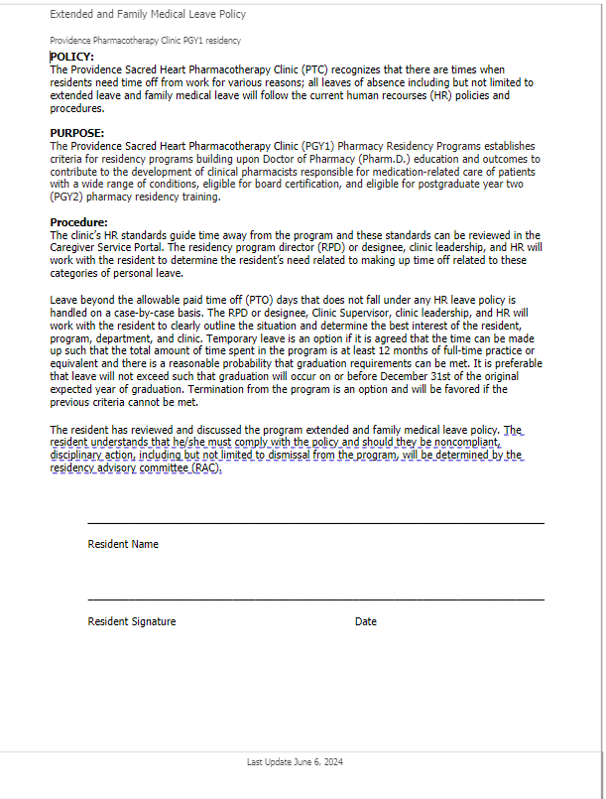

**Appendix C: Duty Hours Policy**

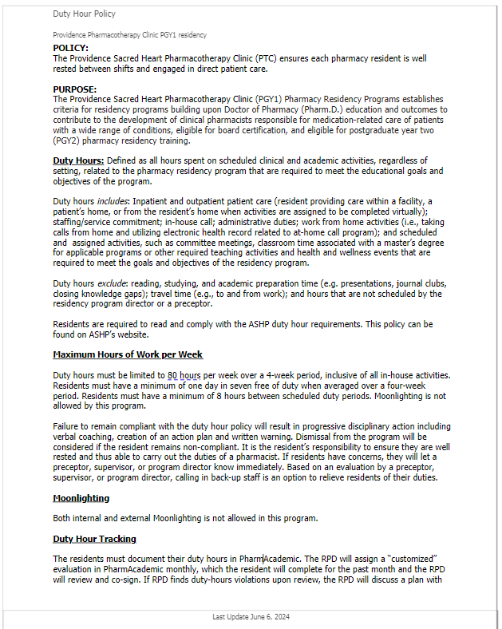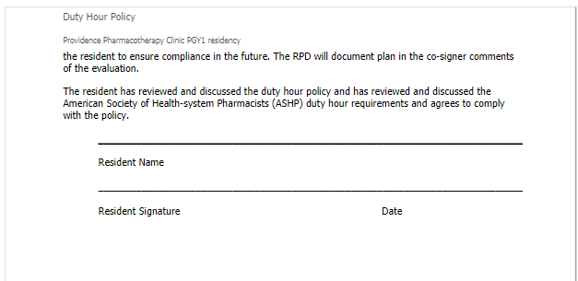

Appendix D: Licensure Policy

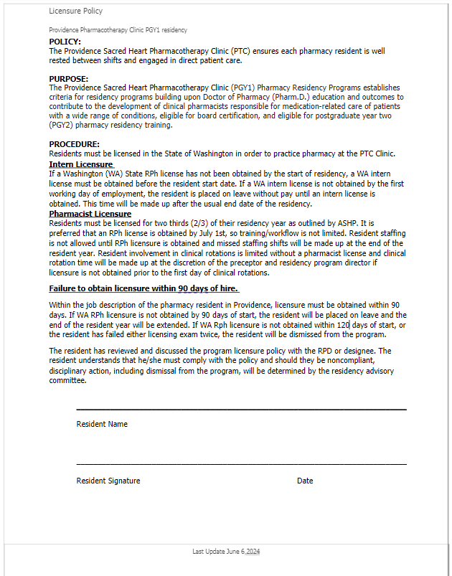

Appendix E: Dismissal and Disciplinary Policy

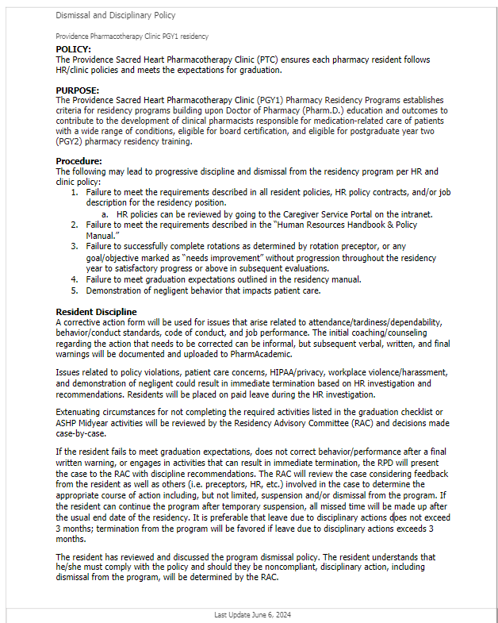

Appendix F: Graduation Checklist

* Satisfactorily complete all rotations
  + Anticoagulation Triage
  + Anticoagulation
  + Centralized Refill
  + Community Outreach
  + Disease State Management 1
  + Disease State Management 2
  + Management
  + Obstetrics
  + Orientation
  + Primary Care
  + Quality Improvement
  + Staffing
  + Teaching Certificate
  + Elective (Geriatrics, Transitions of Care, Informatics, Outpatient Pharmacy)
* “Achieve” 90% (30 out of 33) of all goals and objectives prior to the completion of the residency year
  + R1.1.1 (Analyzing) Collect relevant subjective and objective information about the patient.
  + R1.1.2 (Evaluating) Assess clinical information collected and analyze its impact on the patient’s overall health goals.
  + R1.1.3 (Creating) Develop evidence-based, cost effective, and comprehensive patient centered care plan
  + R1.1.4: (Applying) Implement care plans.
  + R1.1.5: (Creating) Follow-up: Monitor therapy, evaluate progress toward or achievement of patient outcomes, and modify care plans.
  + R1.1.6: (Analyzing) Identify and address medication-related needs of individual patients experiencing care transitions regarding physical location, level of care, providers, or access to medications.
  + R1.2.1: (Applying) Collaborate and communicate with healthcare team members
  + R1.2.2: (Applying) Communicate effectively with patients and caregivers.
  + R1.2.3: (Applying) Document patient care activities in the medical record or where appropriate.
  + R1.3.1: (Applying) Facilitate the medication-use process related to formulary management or medication access.
  + R1.3.2: (Applying) Participate in medication event reporting
  + R1.3.3: (Evaluating) Manage the process for preparing, dispensing, and administering (when appropriate) medications.
  + R1.4.1: (Applying) Deliver and/or enhance a population health service, program, or process to improve medication-related quality measures.
  + R1.4.2: (Creating) Prepare or revise a drug class review, monograph, treatment guideline, treatment protocol, utilization management criteria, and/or order set.
  + R2.1.1: (Analyzing) Identify a project topic, or demonstrate understanding of an assigned project, to improve pharmacy practice, improvement of clinical care, patient safety, healthcare operations, or investigate gaps in knowledge related to patient care
  + R2.1.2: (Creating) Develop a project plan.
  + R2.1.3: (Applying) Implement project plan.
  + R2.1.4: (Analyzing) Analyze project results.
  + R2.1.5: (Evaluating) Assess potential or future changes aimed at improving pharmacy practice, improvement of clinical care, patient safety, healthcare operations, or specific question related to patient care
  + R2.1.6: (Creating) Develop and present a final report.
  + R3.1.1: (Understanding) Explain factors that influence current pharmacy needs and future planning
  + R3.1.2: (Understanding) Describe external factors that influence the pharmacy and its role in the larger healthcare environment.
  + R3.2.1: (Applying) Apply a process of ongoing self-assessment and personal performance improvement.
  + R3.2.2 (Applying) Demonstrate personal and interpersonal skills to manage entrusted responsibilities.
  + R3.2.3: (Applying) Demonstrate responsibility and professional behaviors.
  + R3.2.4: (Applying) Demonstrate engagement in the pharmacy profession and/or the population served.R4.1.1: (Creating) Construct educational activities for the target audience.
  + R4.1.2: (Creating) Create written communication to disseminate knowledge related to specific content, medication therapy, and/or practice area
  + R4.1.3: (Creating) Develop and demonstrate appropriate verbal communication to disseminate knowledge related to specific content, medication therapy, and/or practice area.
  + R4.1.4: (Evaluating) Assess effectiveness of educational activities for the intended audience
  + R4.2.1: (Evaluating) Employ appropriate preceptor role for a learning scenario.
* 90% attendance for each rotation
  + Anticoagulation Triage
  + Anticoagulation
  + Centralized Refill- N/A rotation expectations will be scheduled around PTO
  + Community Outreach- N/A rotation expectations will be scheduled around PTO
  + Disease State Management 1
  + Disease State Management 2
  + Management
  + Obstetrics
  + Orientation
  + Primary Care
  + Qality Improvement - N/A rotation expectations will be scheduled around PTO
  + Staffing - N/A rotation expectations will be scheduled around PTO
  + Teaching Certificate - N/A rotation expectations will be scheduled around PTO
  + Elective (Geriatrics, Transitions of Care, DSM extension, Informatics, Outpatient Pharmacy)
* Reasonable progress of the quality improvement project as determined by the RPD
* Completion and submission of a manuscript to the journal of the resident’s choice
  + Selected Journal:
  + Submission date __________________________
* Successful completion of an administrative rotation with associated projects completed or passed on to the appropriate manager if completion of the project(s) was not anticipated by the preceptor
  + Project ___________________________
  + Completion expectations ________________
  + Completion date: ______________________
* Submission of completed teaching portfolio to Washington State University for approval and issuance of a teaching certificate
* Submission of completed teaching portfolio to Washington State University for approval and issuance of a teaching certificate
  + WSU residency workshop
  + Didactic lecture 1
  + Didactic lecture 2
  + Didactic lecture 3
  + 4 hours of small group/simulation teaching
  + APPE student
  + Residency reflection worksheet
  + Poster presentation
  + Regional Conference presentation
  + IPPE event
  + Attendance at 80 % of journal club/chalk talk activities in clinic
* Attend and present at ASHP Midyear and Regional conference
  + ASHP Midyear
  + Regional residency conference
* Attend Pharmacy Invitational Conference on Antithrombotic Therapy (PICAT) and provide lunch and learns regarding material
  + Attend PICAT
  + Present information to clinic pharmacists
* Complete at least 8 community outreach activities

Appendix G: Sample Post Match Communication

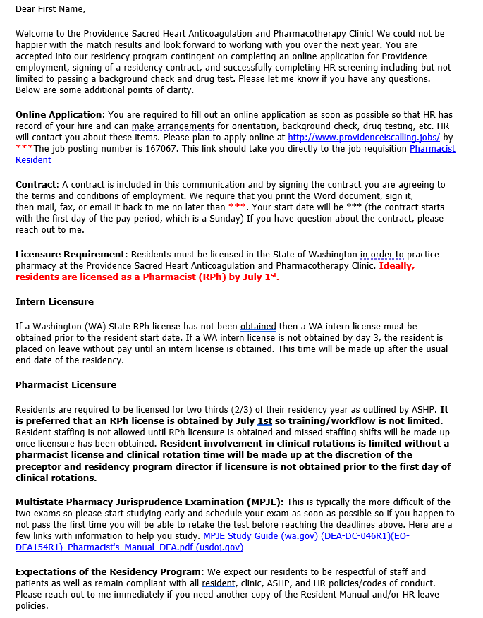

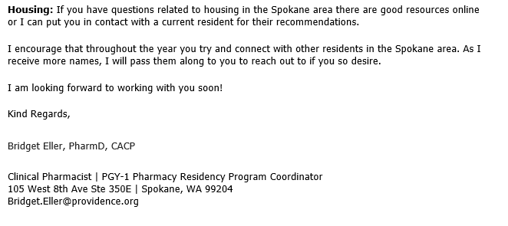

Appendix H: Sample Certificate of Completion

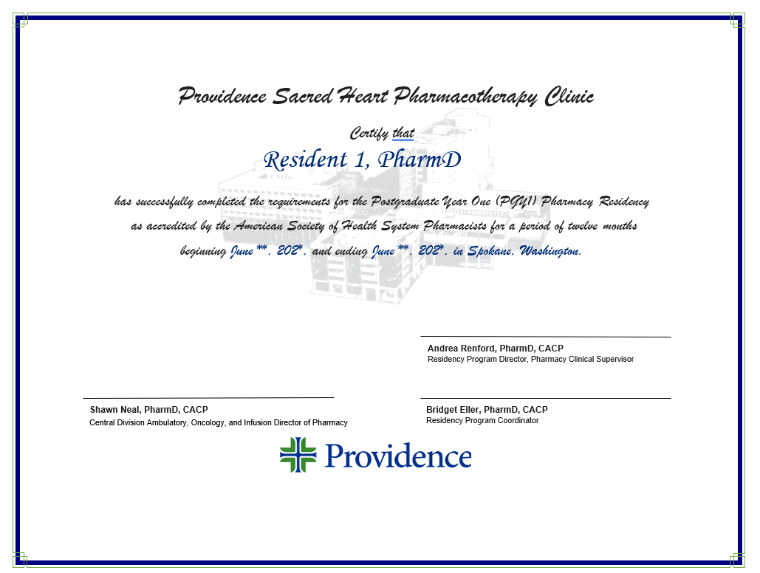

Appendix I: Sample Resident Development Plan

**ASHP PGY1 Development Plan**

**Resident Name:** Text Box

|  |  |  |  |  |  |  |
| --- | --- | --- | --- | --- | --- | --- |
| **Resident’s Self-Reflection and Self Evaluation**  **Self-Reflection includes Strengths, Opportunities for Improvement, Practice Interests, Career Goals, and Well-being and Resilience.**  **Self-Evaluation is related to the Program’s Competency Areas** | | | | | | |
|  | | **Initial** | | **Quarter 1** | **Quarter 2** | **Quarter 3** |
| **Date** | |  | |  |  |  |
| **Personal Strengths and Weaknesses:** | | **From initial self-reflection:**  **Personal Strengths:**  **Personal areas of Improvement:** | |  |  |  |
| **Practice Interests/ Career Goals** | | **From initial self-reflection:**  **Practice Interest (in order of preference):**  **Career Goals:** | | **Changes to:**  **Practice Interests**  **Career Goals:** | **Changes to:**  **Practice Interests**  **Career Goals:** | **Changes to Practice Interests**  **Career Goals:** |
| **Well-being and Resilience:** | | **From initial self-reflection:**  **Current well-being strategies from initial self-reflection:** | | **Current well-being:** | **Current well-being:** | **Current well-being:** |
| **Strengths and Areas of Improvement Related to Competency Areas** | | **R1** | **From Initial Self-Evaluation**  **Strengths:**  **Opportunities for Improvement:** | **Progress on Previous Opportunities for Improvement:**  **Strengths:**  **New Opportunities for Improvement:** | **Progress on Previous Opportunities for Improvement:**  **Strengths:**  **New Opportunities for Improvement:** | **Progress on Previous Opportunities for Improvement:**  **Strengths:**  **New Opportunities for Improvement:** |
| **R2** | **From Initial Self-Evaluation:**  **Strengths:**  **Opportunities for Improvement:** | **Progress on Previous Opportunities for Improvement:**  **Strengths:**  **New Opportunities for Improvement:** | **Progress on Previous Opportunities for Improvement:**  **Strengths:**  **New Opportunities for Improvement:** | **Progress on Previous Opportunities for Improvement:**  **Strengths:**  **New Opportunities for Improvement:** |
| **R3** | **From Initial Self-Evaluation:**  **Strengths:**  **Opportunities for Improvement:** | **Progress on Previous Opportunities for Improvement:**  **Strengths:**  **New Opportunities for Improvement:** | **Progress on Previous Opportunities for Improvement:**  **Strengths:**  **New Opportunities for Improvement:** | **Progress on Previous Opportunities for Improvement:**  **Strengths:**  **New Opportunities for Improvement:** |
| **R4** | **From Initial Self-Evaluation:**  **Strengths:**  **Opportunities for Improvement:** | **Progress on Previous Opportunities for Improvement:**  **Strengths:**  **New Opportunities for Improvement:** | **Progress on Previous Opportunities for Improvement:**  **Strengths:**  **New Opportunities for Improvement:** | **Progress on Previous Opportunities for Improvement:**  **Strengths:**  **New Opportunities for Improvement:** |
| **RPD: Assessment of Strengths and Opportunities for Improvement Related to the Program’s Competency Areas** | | | | | | |
| **Date** |  | | |  |  |  |
| **Strengths:**  **Opportunities for Improvement:** | | | | **Progress on Previous Opportunities for Improvement:**  **Strengths:**  **New Opportunities for Improvement:** | **Progress on Previous Opportunities for Improvement:**  **Strengths:**  **New Opportunities for improvement:** | **Progress on Previous Opportunities for Improvement:**  **Strengths:**  **New Opportunities for Improvement:** |
| **RPD: Planned Initial and Quarterly Changes to the Program\*** | | | | | | |
| **Initial** | | | | **Quarter 1** | **Quarter 2** | **Quarter 3** |
| **Changes Related to Competency Areas:**  **Changes Related to Resident’s Self Reflection:** | | | | **Changes Related to Competency Areas:**  **Changes Related to Resident’s Self Reflection:** | **Changes Related to Competency Areas:**  **Changes Related to Resident’s Self Reflection:** | **Changes Related to Competency Areas:**  **Changes Related to Resident’s Self Reflection:** |

**\*Changes are based on assessment of the resident’s strengths and opportunities for improvement related to the program’s Competency Areas and well as the resident’s self-reflection of personal strengths and opportunities for improvement, practice interests, career goals, and well-being and resilience**.

|  |  |  |  |  |
| --- | --- | --- | --- | --- |
| **Completion Requirements Tracker (Note: Must match requirements in other programs materials such as the program’s manual)**    **Completion Requirements MUST include:**   * **Required deliverables for each program type’s Competency Areas, Goals, and Objective*s (CAGO’s)*** * **The threshold / percentage of objectives that must be Achieved for Residency (ACHR) by the end of the program** * **Appendix Requirements (if the CAGO’s for the residency type (e.g., PGY2) include an Appendix)** | **End of Quarter 1** | **End of Quarter 2** | **End of Quarter 3** | **End of Residency - Final Verification of Completion Requirements**  (*Programs using a separate document for the final “completion checklist” will not need to use this column.)* |
| **ACHR of __% of required objectives.**  **Note: Program determines specific requirements** |  |  |  |  |
|  |  |  |  |  |
|  |  |  |  |  |
|  |  |  |  |  |
|  |  |  |  |  |
|  |  |  |  |  |

___________________________________ ______________________________

**RPD signature** **Date**

___________________________________ ______________________________

**Resident signature** **Date**